Hospital Management System
Project Report

1. Student Details
Name: Kushagra Patil
Roll Number: 24F3002425
Email: 24f3002425@ds.study.iitm.ac.in
2. Project Overview
2.1 What Problem Does This Solve?
During my research, I noticed that many small and medium-sized hospitals still struggle with managing appointments and patient records efficiently. From my own experience visiting clinics, I've seen how messy paper registers can get and how easy it is for appointment slots to get double-booked.
So I decided to create a hospital management system that handles three main pain points:
- Patients wasting time calling to book appointments
- Doctors losing track of patient history
- Hospital admins manually managing everything
2.2 How I Built This
When I started, I knew I wanted to use Flask because I'd learned it in class and felt comfortable with it. Here's how I approached the project:
Step 1: Planning the Database First, I spent time figuring out what data I actually needed. I sketched out the relationships on paper users need to be either admins, doctors, or patients. Doctors need availability slots, patients need appointments, and appointments need treatment records. Once I had this clear, I used SQL to build the database.
Step 2: Building the Backend I started with authentication because that's the foundation. I used Flask-Login which made session management way easier than doing it from scratch. Then I built the routes for each user type. The trickiest part was making sure doctors couldn't book slots that were already taken - I had to add unique constraints in the database.
Step 3: Creating the Frontend Honestly, I'm not great at design, so I kept it simple but functional. I used basic HTML/CSS with some gradients to make it look decent. The main goal was making sure everything was easy to understand and navigate.
Step 4: Testing Everything I created test accounts for each role and went through every feature multiple times. Fixed a bunch of bugs like appointments not showing up because of timezone issues, and the doctor availability form not validating properly.
2.3 Main Features I Implemented
For Admins:
- Dashboard showing overall statistics
- Add/edit/deactivate doctors and patients
- View all appointments across the system
- Search functionality to quickly find people
For Doctors:
- See their upcoming appointments
- Set their available time slots
- Add diagnosis and prescriptions after appointments
- View patient history
For Patients:
- Register and manage their profile
- Browse doctors by specialization
- Book appointments (with checks to prevent double booking)
- View their complete medical history

3. Use of AI Tools
I want to be completely transparent about how I used AI in this project. I used Claude as a learning assistant throughout development, but all the actual problem-solving and implementation decisions were mine.
What I Used AI For:
- Understanding Flask concepts I was stuck on (like how decorators work for routes)
- Getting help with HTML/CSS when my layouts broke
- Debugging errors, it was faster than searching Stack Overflow sometimes
- Generating the initial HTML templates which I then customized
What I Did Myself:
- Designed the entire database schema
- Figured out the relationships between tables
- Wrote all the route logic and business rules
- Decided which features to include
- Tested everything and fixed bugs
- Modified the HTML templates to match my vision
Think of it like having a really knowledgeable classmate helping you understand concepts, but you're still doing your own homework. I learned a ton from this approach - probably more than if I'd just copied code from tutorials.

4. Tech Stack
Backend
- Flask - Main web framework
- Flask-SQLAlchemy
- Flask-Login 0.6 - Handled all the session management stuff
- Werkzeug - For password hashing
- SQLite 3
Frontend
- HTML5 & CSS3 - Kept it simple and responsive
- Jinja2
- JavaScript - Just basic stuff for form validations and modals
Tools I Used
- VS Code with Python extension
- Chrome DevTools for debugging CSS
- DB Browser for SQLite to check my database

5. Database Design
I designed the database with 7 main tables. Here's the logic behind it:
Users Table - This is the base. Everyone has a user account with a role (admin/doctor/patient).
DoctorProfile & PatientProfile - Instead of cramming everything into one Users table, I split it. Doctors have specialization and department info, patients have medical info like blood group.
Departments - Keeps doctor specializations organized.
Appointments - The core of the system. Links patients to doctors with date/time. I added a unique constraint so you can't double-book a doctor.
Treatments - Each appointment can have one treatment record with diagnosis and prescription.
DoctorAvailability - Lets doctors set when they're working so patients know when to book.

Tables and Relationships

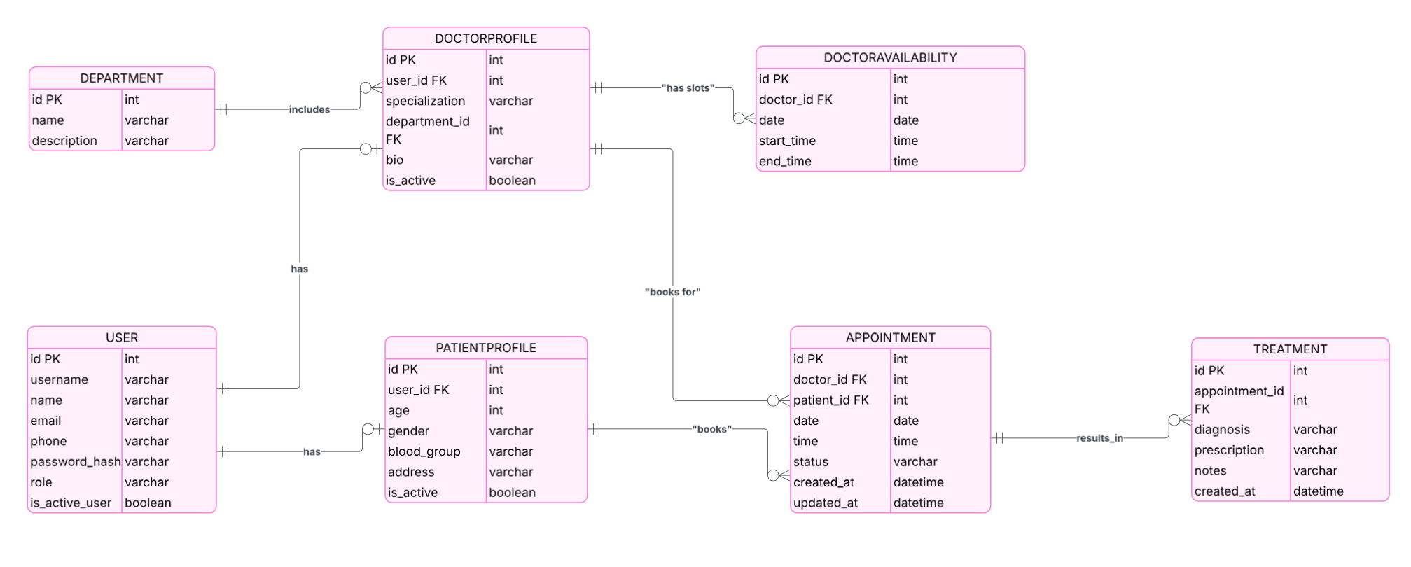
Key Constraints I Added:
- Unique usernames and emails (can't have duplicates)
- Doctor + Date + Time must be unique (prevents double booking)
- Foreign keys everywhere to maintain data integrity
- Can't delete a doctor who has appointments (data safety)

6. API Endpoints
I organized the routes by user role to keep things clean:
Public Routes (Anyone can access)
- GET / - Homepage
- GET/POST /login - Login page
- GET/POST /register - Patient registration (only patients can self-register)
- GET /logout - Logout
Admin Routes (Requires admin login)
- GET /admin/dashboard - Shows stats and recent appointments
- GET /admin/doctors - List all doctors with add/edit options
- POST /admin/doctors/add - Create new doctor account
- POST /admin/doctors/<id>/edit - Update doctor info
- POST /admin/doctors/<id>/delete - Deactivate a doctor
- GET /admin/patients - List all patients
- POST /admin/patients/<id>/edit - Update patient info
- POST /admin/patients/<id>/delete - Deactivate a patient
- GET /admin/appointments - View all appointments
- GET /admin/search?q=<query> - Search doctors and patients
Doctor Routes (Requires doctor login)
- GET /doctor/dashboard - Doctor's main page with upcoming appointments
- POST /doctor/appointments/<id>/status - Mark appointment as complete/cancelled
- GET/POST /doctor/appointments/<id>/treatment - Add diagnosis and prescription
- GET/POST /doctor/availability - Set working hours
- GET /doctor/patients/<id>/history - See a patient's previous appointments
Patient Routes (Requires patient login)
- GET /patient/dashboard - Patient's main page
- GET/POST /patient/profile - Edit personal information
- GET /patient/doctors?specialization=<spec>&department_id=<id> - Browse doctors
- GET/POST /patient/appointments/book - Book new appointment
- POST /patient/appointments/<id>/cancel - Cancel appointment
- GET /patient/history - View all past appointments and treatments
JSON API
- GET /api/appointments - Returns appointment data in JSON format (role-based access)

7. Challenges I Faced
Problem 1: Appointment Double Booking Initially, multiple patients could book the same time slot. I fixed this by adding a unique constraint on (doctor_id, date, time) in the database and checking availability before confirming bookings.
Problem 2: Template Rendering Issues Spent hours debugging why pages showed up blank. Turned out I was mixing standalone HTML with Flask templates incorrectly. Had to learn proper Jinja2 syntax.
Problem 3: Role-Based Access Making sure users could only access their own stuff was tricky. I created a decorator function that checks user roles before allowing access to routes.
Problem 4: Date/Time Handling Python's datetime module was confusing at first, especially when comparing appointment times. Had to learn about date vs datetime vs time objects.

THE VIDEO LINK :
https://drive.google.com/file/d/1I8-NgTHerh-9w0m4rgVhzM0SvJtCdZ7O/view?usp=sharing

